|  |
| --- |
|  |
| Spectroradiometer Color Brick II Operation Manual |
| Customer/Service Version 2.0 |

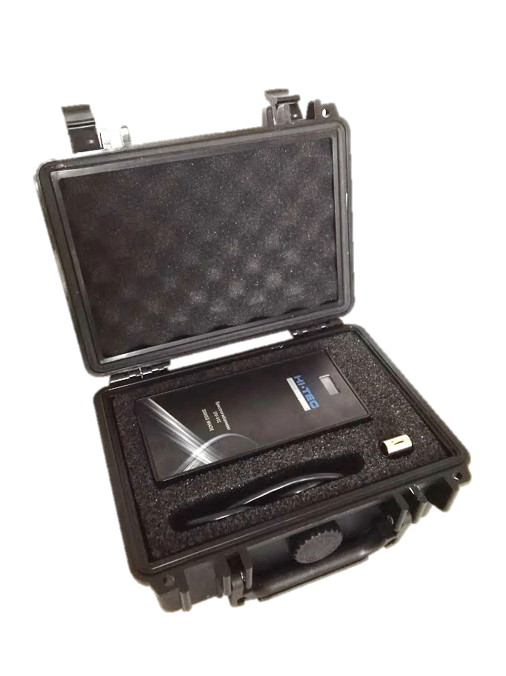

Inhalt

1. Purpose 2

2. Scope 2

3. Requirements 2

4. SW-Installation 3

5. Processdescription 4

6. Save / Print / Retrieve Certificate / Protocol 16

7. Technical Data 19

8. CE-Conformity Declaration 20

1. Purpose

HTS does offer a low cost Spectroradiometer to measure various light conditions spectrally.  
It also calculates and displays light relevant parameters like:

* CCT (Correlated Color Temperature)
* CRI (Color Rendering Index)
* UV-A (amount of UV-A)
* Brightness

This document describes the process of measuring light sources. It describes the required equipment, how to use the measurement device and the software.

1. Scope

The present document describes the “measurement” process.

1. Requirements

The following conditions have to be fulfilled in order to execute the process.

* 1. Tools
* Computer
* Color Brick II (calibrated)
* Notebook, Tablet or Computer with Internet Access
* Installed ColorBrick II Software (is on USB in case)
  + See installation instructions
* USB Cable (is plugged in on both sides)
* Microsoft Excel Version 2010 or 2013 or 2016 installed on Notebook 32 bit Version
* Windows 7 or 8 or 10
  1. Skills
* Operator has to be trained on the use of the SW and the Measurement Device
  1. Preconditions
* The light to measure has to be bright enough and stable

1. SW-Installation
   1. Prerequisites, see above
   2. Run “HS-SR--setup.exe”
      1. Accecpt acces for the installer “Ja” or “ok”
      2. HTS-SR-Setup wizard comes up
         1. Hit Next  
            It shows “unpacking files”
      3. Virtual Serial Driver setup comes up
         1. Hit “Install”
      4. Driver INF installed message comes up
         1. Hit “Done”
      5. Now it installes the files
         1. InstallShield Wizard is installing
         2. Hit “Next”
            1. Wizard asks for your Name and Organisation, please fill in
            2. Hit “Next”
            3. Hit “Finish”
      6. HTS-SR-Setup Wizard tells “Operation Successful”
         1. Hit “Close”
      7. Now the installation is finished and you got a directory “HTS-Spectroradiometer” on your desktop and a link to the SR-Software file with a Hi-Tec-Support Logo
      8. This is your exe-program for your Spectroradiometer
   3. Now check if communication with SR works
      1. Check in Windows which Com Port has been assigned to the Spectroradiometer, search in Devicemanager/COM ports for “Teensy USB serial”, select correct COM Port in the window below and leave Baud Rate at 9600.
      2. Set “Measurement time in ms” to 500 (initially only)
      3. Set number of measurements “# of measurements” to 4

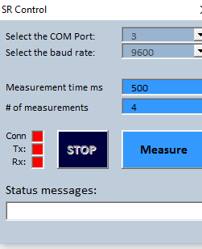

* + 1. Hit Measure
       1. Communication to SR starts
       2. If SR is found it will say connected, you see the communication status bits flicker and it first reads the calibration data from the SR

If your computer does not allow to install unsigned drivers, on windows 8 follow this procedure  
<https://www.craftedge.com/tutorials/driver_install_windows8/driver_install_win8.html>

1. Processdescription
   1. Process:

| ID | Description | Criteria |
| --- | --- | --- |
|  | The following section 1 has only to be performed the first time during a calibration session. Leave this step out for the second and subsequent lamp calibration. |  |
| 1. | Switch on the lamp to test  Waiting time according lamp type:   * LED: 5 minutes * Fluorescence Lamp: 15 minutes * Tungsten and Halogen lamps 1 minute | Lamp has been on at least for defined time |
| 1.1 | Start the computer and connect the ColoBrick II with the computer | Computer is working and the ColorBrick II is connected |
| 1.2 | Start SR-Software  accept ActiveX usage when asked |  |
| 1.3 | Now it should look like this : | SR SW has started |
| 1.4 | **Initialization of Colorbrick**   1. Go to sheet “SR-Control” 2. Hit “Measure”    1. SR Control window setup opens      1. Hit “Measure”    1. Communication to SR starts    2. If SR has been reconnected it will be reading calibration data from SR, then it starts measuring    3. Check then if the SR serial number is the same as on the label of the SR 2. Check on sheet “Certificate” if the “Max ADC value” is between 800 and 1000 units, *this gives best signal noise ratio, but the unit also works well with 500-1000.* 3. In case the value is not between 800 and 1000:    1. Stop communication by hitting “Stop”    2. Increase or decrease integration time and proceed with step 1.4.3. (hit Measure) | Proceed with next step if result within limits. |
| 1.5 | **Calibrate Dark**   1. Calibrate dark 2. Turn the SR upside down so no light enters the Spectroradiometer 3. go to sheet “Control” select “Calibrate Dark” 4. The SR Controls window changes to black to show it is in Calibrate Dark mode, hit Calibrate 5. switch to sheet “Certificate” 6. Initiate a dark check by hitting “Calibrate” |  |
| 1.6 | **basic functional check**   1. turn SR upside straight below your lamp to measure  *it is very important that your Spectroradiometer window is vertically below the light source to measure, as the opening angle of the optics is only about 20°.* 2. hit “Measure”    * + - 1. check if your “Max ADC Value” is in range (ca. 800-1000 units) | Proceed with next step if:  “Certificate” value is between 500 and 1000 units |
| 2.1 | **Set certificate parameters**   1. Go to “SR-Control” 2. Enter your Name 3. S/N of the SR will be loaded automatically from SR 4. Enter Lamp Type / S/N if needed E.g. HTS-C 18W/840 5. Select in drop down menu the lamp you want to check   Choose predefined lamp type, then it takes automatically the correct tolerances for CCT of this lamp and generates an automatic comment on the measurement page. | All three fields are filled in with the right values |

|  |  |  |
| --- | --- | --- |
| 2.2 | **Start measurement**   1. Set “Number of Measurements” to 4 or as many as you want as you can hit Stop whenever you want but do at least 3 cycles 2. hit “Measure” 3. wait until measurement is finished (Stop disappears and Measure is shown again) 4. check if value “Max. ADC Value” is still between 800 and 1000.  if not you get an information message when you try to print the certificate depending the value  *if too high it tells you lower the integration time if too low it tells you to increase integration time to max 2000ms or the lamp is not bright enough*      1. Measurement Page should look like this. | value “Max. ADC Value” is correct proceed otherwise repeat procedure with step “basic functional check” |

|  |  |  |
| --- | --- | --- |
| 3.0 | **Adding new lamps with CCT nominal and tolerances**  Here you can select the lamp against which the tolerances should be measured or  enter new light sources, and the text you would like to see on the certificate it  is located on the page SR- Control |  |

|  |  |  |
| --- | --- | --- |
| 4.0 | **Var SDP**  **software Addin to compare reference and stored SPD (Spectral Data)**  on sheet var SPD click  this form comes up    Here you can select the curves you want to see simultaneously on the graph, with the normalise at wavelength (nm) you enter where the curves are normalised to, then hit , you see then following page    Showing here in blues the actual measurement and in red the selected CIE D65, both curves have the same value at the normalised wavelength here 500nm.  The results are of the actual measurement. |  |
| 4.1 | **Showing Planck curves with this AddIn**  If you want to show the Planck equivalent of the black body temperature, e.g.: 4290 [K] then enter this value to the Planck field, enable the Planck curve and hit refresh chart, as in this example.    You get this result    The yellow is the Planck SPD and the black the actual SPD. |  |
| 4.2 | **Storing actual SPD and displaying stored SPD**  Use these two buttons to store actual SPD and and load stored SPD    If you hit Store Actual SPD you get to this form:    Enter a name, hit ok.  Then it is stored on  file within the same folder.  To load stored SPD hit Load Stored SPD and you get this form    Here you can choose via a pull down menue a stored SPD’s hit Load selected curve or you can delete what you don’t need anymore.  After you have loaded a stored SPD you see it in the form and you can enable to show the curve      Now you see the stored SPD (red) and the actual SPD (blue) and in this case the Planck curve, if selected. |  |
| 4.3 | **Usage of stored data for company QC documentation control etc.**  In the  are all the Spectral Data and colorimeteric data and all the fields of the measurement page stored as text.  You can open it in any text editor or import into Excel or any other data base. The data in it are selfexplanatory. |  |
| 5.0 | **License Key**  On the SR-Control page is a button “Check License Key”  As we have further SW Addins and also additional ones planned, you can buy these and enter here the license key you get from us by E-Mail in this form and hit Verify License Key.    If the SW then finds out that you got a further SW-AddIn, then it stored the new license key on the Memory of the Spectroradiometer.  After the SW has put the license key to your Spectroradiometer, unplug your Spectroradiometer, wait 10 Seconds and replug it. Then your additional SW AddIn’s should come up.  With this system you can install the Application SW on as many computers as you need, the license key is coupled with the Spectroradiometer and it’s serial number. |  |

1. **Save / Print / Retrieve Certificate / Protocol**

|  |  |
| --- | --- |
| **6.1** | **Save Result**  Choose your certificate you want to print    **Service engineers** print the **Cal-Certificate**  Hit Save button or via Datei choose save (speichern)    Then you get this window    Here you choose your place where you would like to store your Secure workbook to retrieve later during startup of SR-.exe.  In this example it is HTSTL827 the extension comes up automatically.  This type of file can only be opened by this program. |
| **6.2** | **Print Result**  Just use normal Windows functions    **Or print to pdf using Microsoft Print to PDF** with this version the document is not changeable anymore and the date and certificate number is fixed |
| **6.3** | **Retrieve stored Results**  Just start your normal SR..exe  You get this window, now Choose Save    Then you get this window, look for your file, select it and open it    Now you have back your original Certificate.  But be **careful**, if you hit measure you overwrite it, but if you do not save it under the same name again you still can reopen the original one.  The only thing that changes is the **certificate number**. |

1. Technical Data

Power Consumption:  
5 VDC 85 mA provided by USB Mini Connector from Computer

Spectroradiometer:

Integration time 10-2000ms

Line sensor with 128 Dioden

10 Bit resolution ( 1000 steps)

Wavelength range: ca. 300-750nm

Luxmeter:

200-6000 Lux

Automatic software calibration dependant on light source

Dimensions:  
65x137x32mm inclusive Siliconcover  
Weight:  
198 g  
Colors:  
Siliconcover: blue

Front plate: Aluminium matt  
  
Typical Tolerances:

|  |  |  |
| --- | --- | --- |
| Brightness [lx] Type A | 200-6000 | +/- 15% |
| Brightness [lx] other lamps | 200-6000 | +/- 25% |
| Color Temperature CCT [K] | 2000-9000 | +/- 5% |
| Color Rendering Index CRI | 0-100 | +/- 4 |
| Ultraviolett Brightness UV-A [mW/cm2] | 0-0.3 | +/- 25% +/-0.01 |

Operating conditions:

15°C to 30°C; 20-75% RH, non condensing humidity

Stocking temperature:

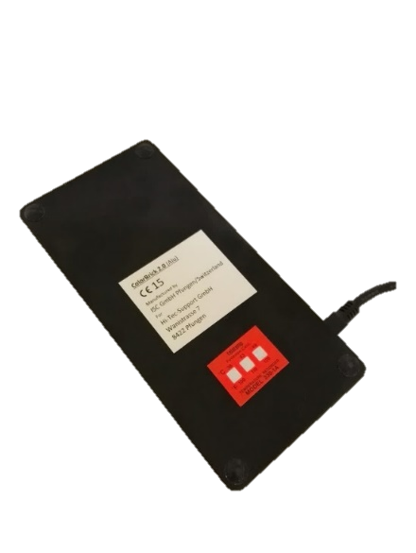0°C to 40°C (please see [Irreversible Temperature Recording Labels on back of instrument)](http://www.telatemp.com/c/186/temperature-tags-labels-irreversible-labels)

1. CE-Conformity Declaration

